http://utq.edu.iq))Thi – Qar University Website
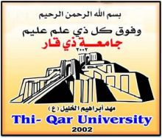

College of Science / Thi-Qar University

Manuscript Title

A Graduation Research Project submitted to the Council of Pathological Analysis Dept. as a Part of Requirements of Bachelor Degree in Pathological Analysis

By B.Sc. Students

Supervisor

2016 -2017

Pathological Analysis Dept. Website College of Science Website
http://pathanadept.sci.utq.edu.iq http://sci.utq.edu.iq/ar

